COMSATS UNIVERSITY ISLAMABAD

11/2/2021

REG # :FA21-BSE-057 NAME: MAHAD WAJID

ISLAMIC STUDIES

ASSIGNMENT- 02



Question:

The Holy Quran is started with the Surah Al-Fatihah; however, it was not first the surah which revealed. Explain the expediency of Surah Al-Fatihah as a first surah of the Holy Quran.

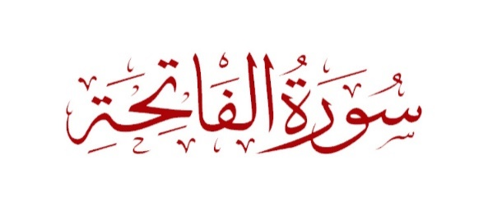

SURAH AL -FATIHAH:

Surah Al-Fatihah is the first Surah of the Holy Quran. This is the Surah which contains seven verses which are very important for us in terms of knowing the whole summary of Quran. Some scholars said the summary of Quran is Surah Al-Fatihah. Its seven verses (Ayat) contain a prayer for the guidance, lordship and mercy of Allah Almighty. The meaning of al fatihah is “The Opening”. This is makki surah revealed before the migration of the Holy Prophet (PBUH) to Yathrib (Madinah). This surah is recited in every rak’ah of every prayer. It was first surah to be revealed at whole.

In terms of importance, it is known as Umm al-Kitab and Umm al-Quran. It is the summary of entire Quran. There are many virtues associated with this Surah. This is the Surah that Allah (SWT) recommend us to recite in every prayer in every Rak’ah. Its must something important so important for us is to understand it. This Surah Al-Fatihah actually is broken up into two parts, halves one part is when we are praising Allah (Subhanahu Wa Ta'ala) and then there is a contract and then after that there is dua. When we praise Allah (Subhanahu Wa Ta'ala) Allah responds back to you.

The expediency of Surah Al Fatihah as first Surah of Holy Quran:

It is called Al-Fatihah, the Opening - as it opens the Book and with it, the recitation in prayer commences. It is likewise named Umm al-Quran- the mother of the Quran, and Umm al Kitab, the mother of the Book due to the fact the which means of the whole Quran is summarized therein. It is likewise named Sab'ul-Mathani, (the Seven Often Repeated Verses), Al-Hamd, Al-Shifa, Ar-Ruqya

Its recitation is a circumstance for the effectiveness of the prayer. This Surah teaches us to follow the right path and do good deeds and pray Allah that Allah guide you to right path. Surah Al-Fatihah has great virtue in it especially when it comes to illnesses, cures.

CURE OF HEART:

This chapter contains a supplication for protection from misguidance and anger of Allah. This thus protects the heart from corrupt knowledge and evil intentions. The hidden cure to both this illness is also found in the verse:

“You (Oh Allah) we worship and from you we seek help.”

**(Verse 05, Surah Fatihah)**

GREATEST SURAH IN QURAN:

When the Prophet Muhammad (SAW) said to a companion that He would teach him the greatest chapter in the Qur’an, He recited Surah Al-Fatihah.

MOTHER OF QURAN:

It is the mother of Qur’an. The prophet Muhammad (PBUH) said that:

“Al-Fatihah is the mother of Qur’an, the mother of the book, the seven oft-repeated verses and the great recitation.

**(Tirmidhi)**

PILLAR OF THE PRAYER:

The Surah Fatihah is a pillar of the prayer. This Surah is also an essential part of our daily prayers and hundreds of thousands of Muslims recite it for protection and all other circumstances. This Surah is also an essential part of our daily prayers and hundreds of thousands of Muslims recite it for protection and all other circumstances.

ANTIDOTE TO DISEASE OF SOUL:

Surah Al-Fatiha is the opening Surah of the Holy Quran and is considered one of

the most powerful Surahs in the Holy Book. ... It hence also entails the cure for spiritual ailments, and Surah Al-Fatiha is considered one of the strongest antidotes to diseases of the soul, including the evil eye.

MAIN IMPORTANCE OF SURAH AL-FATIHA:

The Opening" or "The Opener") is the first surah (chapter) of the Quran. It consists of 6 or 7 ayat (verses) which are a prayer for guidance and mercy. Al-Fatiha is recited in Muslim obligatory and voluntary prayers, known as **SALAH.**